Student teacher’s name: |  | Supervisor’s name:
Lesson number in sequence e.g. 2 in 5 | Duration of Lesson:  30 mins | Class Size: 20-21 | Year level:  10  Australian Curriculum level:  9-10
Topic of lesson: Fitness
Specific focus of the topic: Cardiorespiratory fitness

Learning Objective/s
- Psychomotor: Students increase their cardiorespiratory fitness through a group fitness session.
- Cognitive: Students justify the selection physical activities within the group fitness session and link them to the improvement of cardiorespiratory fitness.
- Affective: Students work with others in order to increase motivation to complete the group fitness session.

Strand/s:  Health and Physical Education | Domain/s:  Movement and Physical Activity | Dimension/s:  Moving our body
Design, implement and evaluate personalised plans for improving or maintaining their own and others’ physical activity and fitness levels

Assessment criteria and method of evaluation
Standards (taken from above) | Assessment criteria (what | Evidence (how will you know the standard has been achieved?)
Students implement personalised plans for improving or maintaining their own and others’ physical activity and fitness levels. | Are students able to successfully participate in the cardiorespiratory fitness session in order to maintain or improve their own physical activity and fitness levels? | Students successfully participate in the cardiorespiratory fitness session in order to maintain or improve their own physical activity and fitness levels
Justifying the selection of physical activities included in a personalised plan linked to the components of health- and skill-related fitness they wish to improve or maintain | Are students able to justify the selection of physical activities within the group fitness session and link them to improving cardiorespiratory fitness? | Through questioning, students will justify the selection physical activities within the group fitness session and link them to the improvement of cardiorespiratory fitness.

Equipment required for the lesson
Mats | Bean bags
Balls | Station booklets x 4
Station numbers 1-7 and letters | Skipping ropes and boxing equipment

Stage/Time | Tasks | Teacher Action/ Focus questions
Stage 1  Introduction  5 mins | Administration  - Take roll  - Introduce lesson activities
Stage 2  5 mins | Warm up: Animal relays  Teams of 4-5. Do 2-3 relays  Animals  Bear crawl: Walk on hands and feet- alternate leg and opposite hand  Frog Jumps: Full squat to floor, jump back into full squat  Crab walk: walk on hands and feet sideways, but facing ‘up’- making a bridge  Donkey Kicks: Hands on floor, kick both feet into air, land, jump forward  Gorilla Run: Squat position, jump forward, landing on one foot after the other | - Demonstrate relays  - Set up groups now for next activity
15 mins | Fitness Race (Appendix 1)  Groups of 5-6  Students complete a fitness race, similar to the amazing race; at each station the team must complete an exercise (usually in pairs) in order to obtain a letter. Once all letters are collected, as a group they need to assemble the word and report to their teacher.  MAGIC WORD: FITNESS  G1 – start at station 1  G2- start at station 4  G3- start at station 2  G4: start at station 3  G5: Start at station 5  Alternatively set this up moodle. | - Set stations up around gym- needs to be done before class.  - Each group receives a booklet each. Each group will start on a different station. If they find they are at another station with another group- find an empty station.  - Randomise groups so students are working with different people.  - Demonstrate stations where necessary- however booklet should be self-explanatory.  - If students need help during the activity- float around to help, clarify and demonstrate where necessary.  - Some stations require timing therefore be available to do this where needed.  Ensure students are completing exercises using correct technique
Stage 3  Conclusion | Transition period between gymnasium and gym or dismissal | - For those students who finish race early- get them to try team plank or undertake stretches.
Stage 4
Closure

Resources required in the development of the lesson/unit plan:

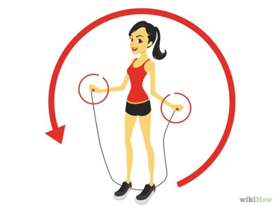
Station 1: SKIPPING

Each person must:

10 x skip forwards

10 x skip backwards

10 x Criss-crosses

10 x Double jumps
(If you cannot do double jumps then repeat one of the above)

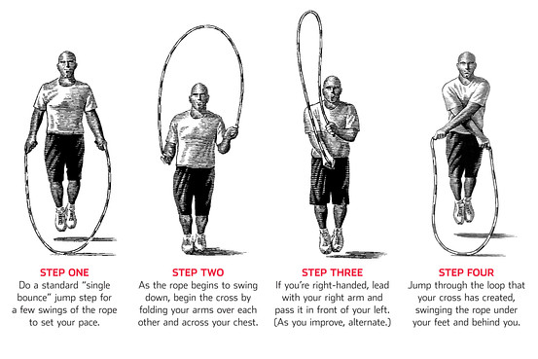

Once each person has completed this exercise successfully, collect the letter and move onto station 3. If finished- see last page!
Station 2: LAP IT!

Each person must complete a lap of the oval. Here is the catch!

1 person must run around the oval
1 person must perform heel flicks around the oval
1 person must side step around the oval
1 person must perform high knees around the oval
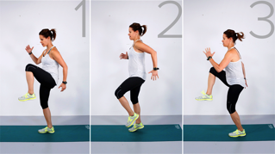
1 person must run backwards
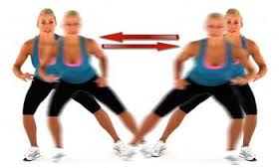
High knees
Side stepping

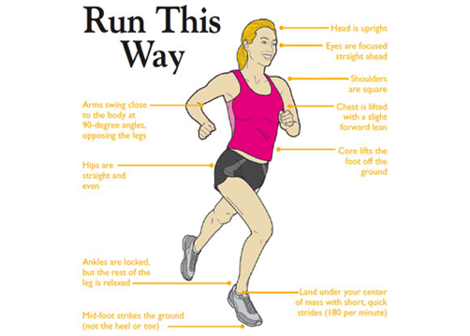
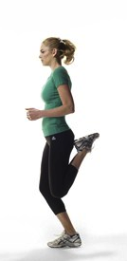

Once everyone has successfully completed a lap of the oval, collect a letter and go to station 7.

Station 3: CORE

Each person must complete:

1. 10 x Partner sit-ups with ball.

Lay opposite each other with feet touching and knees bent in sit up position. One person starts with the ball. As each person completes the up phase of the sit up the ball must be passed from one person to the other. Each person then completes the down phase. Repeat for 20 passes. EASIER: do not do full sit ups!

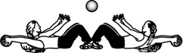

2. 20 x Mountain climbers- 10 each leg (individual)

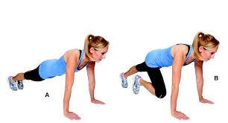

3. 10 x Bicycle crunches (individual)

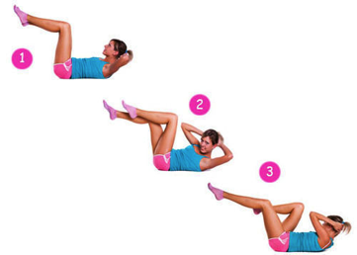

Once everyone has successfully completed the core exercises, collect a letter and go to station 5.
If finished- see last page!
Station 4: TEAM PLANK

In your groups you can either complete an individual plank or a partner plank for an extra challenge. The plank must be held for 30 seconds.

Harder: plank on your hands
Easier: plank on your knees

This is what a partner plank looks like!

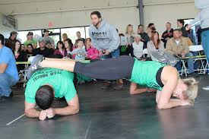

Take note on the key tips of planking

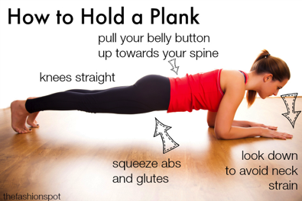

Once everyone has successfully completed the team plank, collect a letter and go to station 6.

Station 5: BOXING

Each person must box for 1 min. This means you will need to take it in turns holds the pads and wearing the gloves!

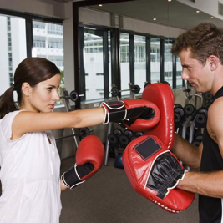
Once everyone has successfully completed the boxing task go to station 4.

Station 6: WALK LIKE A CRAB!

Starting from the baseline at the end of the basketball court, each person must crab walk to the opposite baseline (full court) completing a crab walk. When doing a crab walk, you must balance a bean back on your stomach. If this falls off you must start again. Only one person at a time can complete the crab walk.
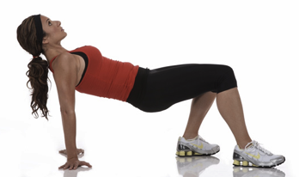

Once everyone has successfully completed the crab walk, collect a letter and go to station 2. If finished- see last page!

Station 7: LEGS

Each person in your group must complete:
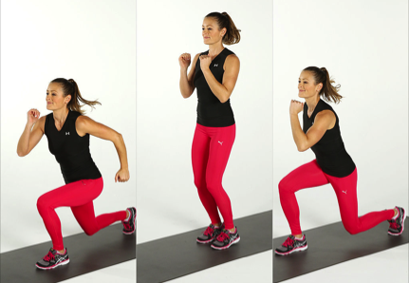
3. 10 x scissor jumps- also known as split lunges

Note:
- Keep back straight
- Make sure legs are wide apart
- Bring back knee down as far as you can

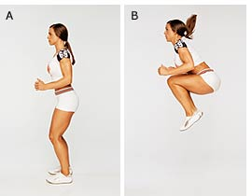

2. 10 x tuck jumps
These need to be explosive and continuous

3. 10 x squat jumps
Note: Keep back straight!
Go as low as possible
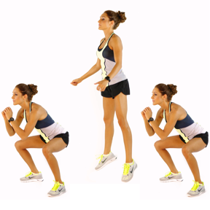
Keep legs slightly wider than shoulder-width apart

Once everyone has successfully completed, collect a letter and go to station 1.
If finished- see last page!

WELLDONE!

You have successfully completed all of your stations.

It is now your job to arrange the letters you have been given and create the MAGIC WORD! Once you know the magic word report to your teacher to see if you are correct!

1
2
3
4
5
6
7
F | F
F | F
I | I
I | I
T | T
T | T
N | N
N | N
E | E
E | E
S | S
S | S

