Unit 3: Signatures of life
Area of Study 1: Molecules of life
By Melissa Carusi: 211298467 and Jett Prout: 211261366
Unit 3, Area of Study 1, Molecules of life requires students to explore the processes of cells at a molecular level [1]. This includes acquiring knowledge and applying their understanding in relation to a range of concepts such as the synthesis of bio macromolecules, identifying the energy requirements of cells through cellular respiration and photosynthesis, gaining an understanding that DNA and proteins are the vital molecules of life and that DNA codes for the production of proteins [1]. Throughout this area of study students will undertake many practical investigations as well as group activities surrounding the molecular composition of cells, biochemical processes and enzyme activity [1]. Molecular biology in medical diagnosis will also be another concept that students will get the chance to explore and then apply their knowledge of this through a School Assessed Course work (SAC) [1].

“On completion of this unit, students will be able to analyse and evaluate evidence from practical investigations related to biochemical processes” [1]. In order to achieve this outcome, students will undertake a range of formative assessments throughout this area of study. Students will undertake 2 SACs, which will contribute to their overall study score for units 3 and 4. The SACs undertaken by students will relate to the key knowledge and key skills that are addressed in the Victorian Certificate of Education Biology study design and therefore through the SAC practical investigations, students will be able to analyse and interpret results and then apply this evidence to the key concepts in biology. As a result, students are given the opportunity to draw upon the key knowledge and key skills needed in order to complete this area of study satisfactorily.

Besides SACs, students will also have the opportunity to draw upon the key knowledge and key skills outlined through general practical investigations and group work activities, which will be formally assessed by the classroom teacher. These formal assessments will allow both the teacher and student to analyse the student’s progress and therefore allow for improvements to be made if required. Students will also be assessed on their contribution to classroom discussion, class attendance and completion of homework.

This Area of study will run over the duration of 8 weeks with 4 lessons running per week (2 single 50 minute lessons and 1 double 100 minute lesson). There will be 2 SACs undertaken by students in week 3 (movement across membranes) and week 6 (biochemical processes) where students will draw upon key knowledge and key skills required to successfully complete the unit. All other weeks will cover and review the relevant content required through a range of teaching and learning approaches.

This area has been designed to give students a range of revision resources that student’s will use mostly outside of the classroom such as power points, concept maps and chapter review questions, while at school students will be immersed in as many practical’s and inquiry based learning activities as possible. Each week will involve one practical class, while other classes throughout the week will involve class investigations and activities usually undertaken in groups. This will allow students to reinforce their knowledge of key concepts acquired through the revision resources provided and give students the opportunity to apply key skills. There is a range of You Tube video links provided throughout the area of study, which students can use in class as well as home. This provides students a visual and auditory method of explanation to acquire a deeper understanding. Web links to practical investigation’s and activities undertaken will also be provided to students. Depending on the school’s practices, students will be required to construct a glossary of unfamiliar or confusing biology terms to a biology classroom study page set up on the intranet or Facebook. Students can refer to this anytime throughout class or at home. It is preferred that students purchase the Heinemann Biology 2 textbook, as it will be used. However, it is important to note that it will not be the primary teaching tool, but rather another resource that will aid in giving students a different explanation of key concepts in order to aid in a deeper understanding. Throughout the area of study, particularly in regards to revision for SACs and exams, students will undertake a range of practice exam questions from past papers in order to practice skills such as how to approach an exam or SAC question and looking for key indicator words.

Reflective statement of personal learning

Coming into this unit I didn’t really think of myself, as a biology teacher and the thought of teaching biology made me feel quite worried. I felt as though the content was very complex and something that I myself would have trouble delivering to students and therefore the thought of teaching it made me feel quite inadequate.

As a consequence of completing this task, it has made me more comfortable with the thought of teaching VCE biology. Through undertaking this assignment, I have been able to do a range of research and have come across many websites that provide great biology resources. Not only do these resources provide many great inquiry-based learning activities, but also a wide range of laboratory practical’s, You Tube videos and revision tools and worksheets that directly relate to the key knowledge and key skills that students need to achieve. Having access to all these resources will be very beneficial in my future teaching not only in the delivery of content, but will also allow me to address the needs of a range of different learners. Through this assignment, I also got the chance to source a School Assessed Course Work and write up assessment criteria in accordance with performance descriptors, which will be very helpful when it comes to writing up my own School Assessed Coursework.

 | Area of Study: Outcome | Key Knowledge: | Teaching Focus, Activity or Assessment Task: | Key Skills: | Reference:
1 | Unit 3, Area of Study 1: Molecules of Life  Outcome:  “On completion of this unit the student should be able to analyse and evaluate evidence from practical investigations related to biochemical processes.”[1] | •The role played by organelles. | •Introduction to the Area of Study and quick revision of units 1 & 2.  •Tour of the animal and plant cell and their organelles  •Cells, the cell theory, prokaryotes, eukaryotes, organelles.  •Biological molecules  •Construction of a growing glossary. Students to add unfamiliar or confusing terminology to the biology study page on the intranet or Facebook (dependant on school practices)  •Prac: Elodea under the microscope. Microscopy and cytoplasmic streaming. (Formative assessment, non- official marking out of 10)  •Revision: celebrity organelles: observe information retained regarding prokaryotes, eukaryotes & organelles  Homework : Selected revision questions Heinemann Biology 2 [2] Chapter 1 | Apply biological understandings: make connection between concepts – between the study of organelles and the prac, viewing of chloroplasts. | •Heinemann Biology 2 [2] Chapter 1 The Chemical Nature of Cells  •Tour of the plant cell:  http://www.youtube.com/watch?v=ASYG1JQy7K4  •Tour of the animal cell:  http://www.youtube.com/watch?v=4DWaAIVlW3k  •Revision PowerPoints for cells and organelles, Cell Types and Cell Structure  http://www.sciencegeek.net/Biology/Powerpoints.shtml  •Cytoplasmic streaming video: http://www.youtube.com/watch?v=pFsty-XyLZc  •Elodea practical:  http://www2.mrc-lmb.cam.ac.uk/microscopes4schools/elodea.php  Students are required to submit a drawing of what they saw under the microscope in both hypotonic and hypertonic conditions. Assessment would be based on accuracy, correct layout of the drawing (title, scale, date and student’s name) and correct labelling of chloroplasts, cytoplasm and cell wall.
2 |  | •The fluid-mosaic model.  •The structure and function of lipids and their sub-units.  •The structure and function of the plasma membrane and the movement of substances across it. | •SAC preparation.  •Revision: Diffusion and osmosis crossword puzzle  •Revision: Cell membrane images  •Prac, small groups – plasticine model of either cell membrane or cell and organelles. To be labelled and students to explain to class one aspect of permeability shown in model.  (Formative assessment, non- official marking out of 10, 5 for involvement, 5 for understanding)  Homework : Selected revision questions Heinemann Biology 2 [2] Chapter 1 | Communicate biological information and understandings. | •Heinemann Biology 2 [2] Chapter 1 The Chemical Nature of Cells  •Revision: Diffusion and osmosis crossword puzzle:  http://www.biologycorner.com/worksheets/diffusion_osmosis_crossword.html#.UlY66GSwXd4  •Revision: Cell membrane images  http://www.biologycorner.com/worksheets/cell_membrane_images.html  •Revision PowerPoints for cells and organelles, Cell Types and Cell Structure, for cell membranes, Membranes: Structure and Function  http://www.sciencegeek.net/Biology/Powerpoints.shtml  •YouTube video, the fluid mosaic model:  http://www.youtube.com/watch?v=Qqsf_UJcfBc  •YouTube video, membrane transport:  http://www.youtube.com/watch?v=2UPqLm-uDnI  Each group of students would be given a range of plasticine colours. Cell membrane models must include a depiction of the phospholipid bi-layer with included carbohydrates and embedded proteins. Cell models must include the major organelles relevant to the chosen cell type (animal or plant) For example; Plant - smooth ER, rough ER, Golgi apparatus, vesicles, lysosomes, mitochondria, nucleus, ribosomes and vacuoles. The explanation should be limited to a few minutes.
3 |  | • Enzymes as protein catalysts.  • Catabolic and anabolic reactions.  •The structure and function of the plasma membrane and the movement of substances across it. (SAC) | •SAC 1: Formal assessment - Movement across membranes.  Lab report: A written report of a practical activity on the movement of substances across membranes. (25 marks)  (Note: This SAC can either be done over 3 periods at school or a day excursion to the GTAC specialist centre)  •Enzymes revision power point  •Small group activity with each doing a short (10 minute) investigation for presentation to the class, on an everyday enzymatic process such as cheese making, alcohol production, bread making – how do the enzymes do what they do?  (Formative assessment, non- official marking out of 10, 5 for involvement, 5 for understanding)  Homework : Selected revision questions Heinemann Biology 2 [2] Chapter 2 | Investigate and inquire scientifically.  Communicate biological information and understandings. | •Heinemann Biology 2 [2] Chapter 2 The Nature of Biochemical Processes  •SAC 1: Formal assessment (See appendix)  Revision power points for enzymes, Enzymes: A Cell’s Catalysts  http://www.sciencegeek.net/Biology/Powerpoints.shtml  •Group activity should be marked on understanding pertaining to what the enzymes actually do in the chosen example as well as participation.
4 |  | •Synthesis of biomacromolecules.  •The structure and function of lipids and their sub-units.  •Packaging, transport, import & export of proteins and other important biomacromolecules. •The role of the organelles in the export of proteins.  •ATP and ADP – energy transformations | •The first 4 Key Knowledge points may be taught in one lesson building on the knowledge already learned about cells, membranes and transport.  •The nature of biochemical processes  •Biomacromolecule-poster/table group activity. (Formative assessment, non- official marking out of 10, 5 for involvement, 5 for understanding)  •Revision: Biomacromolecule chart.  •Energy transformations can be problematic to learn and this should be the focus of this and next week’s lessons.  •Introduction to cellular respiration animation  •Prac: Role-play of cellular respiration.  (Formative assessment, non- official marking out of 10, 5 for involvement, 5 for understanding)  Homework : Selected revision questions Heinemann Biology 2 [2] Chapter 3 | •Apply biological understandings  •Communicate biological information and understandings. | •Heinemann Biology 2 [2]  Chapter 3 – Energy Transformations  •Revision PowerPoints for biomacromolecules, Biochemistry – the chemistry of life.  http://www.sciencegeek.net/Biology/Powerpoints.shtml  •Biomacromolecule-poster group activity  http://biologyteaching.files.wordpress.com/2012/11/organic-molecules-poster-group-activity.docx  •Biomacromolecule-revision chart.  http://www.biologyjunction.com/Macromolecules%20chart.doc  •Cellular respiration animation  http://www.sumanasinc.com/webcontent/animations/content/cellularrespiration.html  • Cellular respiration role-play taken from:  http://www.google.com.au/url?sa=t&rct=j&q=&esrc=s&source=web&cd=1&ved=0CCwQFjAA&url=http%3A%2F%2Fwww.coe.unt.edu%2Fsites%2Fall%2Ffiles%2Fxtreem%2Fbio%2FRevised%252011_30_08%252017%2520Biology%25209b%2520Cellular%2520Respiration.doc&ei=EjZTUoTEJs3tiAfnxICICw&usg=AFQjCNE4KW8bkWOcgnowas_o1HfnxgFzTw&bvm=bv.53537100,d.aGc
5 |  | •Requirements for photosynthesis  •Requirements for aerobic and anaerobic cellular respiration. | •Introduction to photosynthesis animation  •Prac: Test for carbon dioxide in expired air.  (Formative assessment, non- official marking out of 10)  •Revision: Photosynthesis concept map  •Revision: Respiration concept map  •Revision: Photosynthesis and respiration rags to riches- class quiz  Homework : Selected revision questions Heinemann Biology 2 [2] Chapter 3 | •Investigate and enquire scientifically. | •Heinemann Biology 2 [2]  Chapter 3 – Energy Transformations  •Prac instructions from:  http://www.teachingbiologyproject.org.za/?page_id=971  •Revision: Photosynthesis and respiration rags to riches- class quiz  http://www.quia.com/rr/34827.html?AP_rand=928898062  •Photosynthesis animation  http://www.learnerstv.com/animation/animation.php?ani=179&cat=biology  •Revision: Photosynthesis concept maps  http://www.biologyjunction.com/Light%20Reactions%20concept%20map.doc  http://www.biologyjunction.com/Dark%20Reactions%20concept%20map.doc  •Revision: Respiration concept map  http://www.biologycorner.com/worksheets/conceptmap_cellresp.html
6 |  | •The structure and function of DNA & RNA | •SAC 2: Formal assessment - Biochemical processes.  Scientific poster: An annotated poster (in electronic format) related to a biochemical process chosen from a topic list. (25 marks)  •Work with models of DNA, or could construct from straws or paper. •Help students with mnemonics for purines, pyramidines and base pairing.  • Revision: Codon worksheet  Homework : Selected revision questions Heinemann Biology 2 [2] Chapter 4 | •Investigate and enquire scientifically.  •Apply biological understandings  •Communicate biological information and understandings. | •Heinemann Biology 2 [2]  Chapter 4 – DNA, proteins and proteomes.  •Topics for the scientific poster would be chosen from the text. Other topics would be considered, but must be approved by the teacher before starting research for the poster.  •Revision PowerPoints for the structure and function of RNA and DNA, DNA: Structure and Replication and RNA: Structure, Transcription and Editing  http://www.sciencegeek.net/Biology/Powerpoints.shtml  •Revision: Codon worksheet  http://biologyteaching.files.wordpress.com/2012/11/codon-worksheet.docx
7 |  | •The nature of the proteome.  •Protein synthesis and structure | •The chemical nature of the cell.  •Applications of molecular biology  •Build models showing the four levels of protein structure.  Materials are provided, string, pipe cleaners, plasticine, beads, paper etc. but the ideas are to come from the students. They make their own representations and explain them.  (Formative assessment, non- official marking out of 10, 5 marks for involvement, 5 for understanding)  •Revision: Breaking the code worksheet  Homework : Selected revision questions Heinemann Biology 2 [2] Chapter 3 | •Apply biological understandings  •Communicate biological information and understandings | •Heinemann Biology 2 [2]  •Chapter 4 – DNA, proteins and proteomes.  YouTube video on protein synthesis:  http://www.youtube.com/watch?v=NJxobgkPEAo  YouTube video on protein structure:  http://www.youtube.com/watch?v=lijQ3a8yUYQ  •Revision: Breaking the code worksheet  http://biologyteaching.files.wordpress.com/2012/11/protein-synthesis-breaking-the-code-worksheet.pdf
8 |  | •Revision and practice exam. | •Practice exam – students to mark as a class  •Revision classes will focus on areas where students had most difficulty. | •Apply biological understandings  •Communicate biological information and understandings. | •Revision PowerPoints for the structure and function of RNA and DNA, DNA: Structure and Replication and RNA: Structure, Transcription and Editing  http://www.sciencegeek.net/Biology/Powerpoints.shtml

Homework: Homework questions based on the text would be chosen to check understanding of those things that may have been passed over quickly in class. Students should have read the chapter to be able to answer some of the questions. Students discuss homework answers each week in small groups or as a class, depending on the school and the students.

Timing of lessons: This Area of Study outline is based on four 50 minute lessons per week arranged as two single lessons and one double. Even the shorter practical activities would usually be held during the double lesson, as in some schools the double lesson may be the only one timetabled in a lab room.

Key: Bold type within the table indicates a piece of School Assessed Coursework (SAC) that is counted toward the study score. Other assessments are formative and allow both teacher and student to judge the student’s progress.

Marking: General considerations in formative assessment would include contribution to class discussion, attendance (if permitted by school policy) and completion of homework.

Revision: The revision tasks provided throughout the unit can be undertaken by student in class (if time permits) or at home in order to be used as a revision tool to further reinforce their understanding of key concepts and apply key skills. Some of these tasks can be added to student’s study notes to aid them in future revision for SACs and exams.

References:
1. VCAA, Biology: Victorian Certificate of Education Study Design, V.C.a.A.A. (VCAA), Editor 2012, VCAA: Melbourne.
2. Evans, B., et al., Heinemann Biology 2 Enhanced. 4 ed2012, Port Melbourne: Pearson Australia.

Appendix:
Appendix 1 on following page, SAC 1 task, formal assessment.

Unit 3, AOS1: Outcome 1 SAC task 1
(FOR STUDENTS)

This SAC will contributes 25 marks towards the total 50 marks for School Assessed Coursework for unit 3, outcome 1

An investigation of movement of substances across selectively permeable membranes

- This SAC will run over 3 classes (1 x50 min, 1 x100min)

Stage 1:
2 lessons prior to your practical, you will be given a copy of the aims, materials and methods of the laboratory investigation regarding the movement of substances across a selectively permeable membrane. DATE:

Stage 2:
For Part A of this practical, you will set up the laboratory investigation in pairs or groups of 3-4. This will be a 50-minute session where you will conduct pre-dialysis tests. In this session you will be assessed on your collection and presentation of practical results and safe laboratory practice. Your report will be collected at the end of this session and returned to you for PART B of the SAC. DATE:

Stage 3:
For Part B, you will undertake an 80-minute results collection and writing session. Your unfinished report will be returned to you and you will collect and record post dialysis results. Again you will be assessed on your collection and presentation of practical results and safe laboratory practices. Additionally you will be provided with a set of questions which you will answer in regards to your evaluation of experiment procedures, results of the practical and application of understanding relating to the movement of substances across the cell membrane (including proteins), with reference to the fluid mosaic model of the plasma membranes. DATE:

(GTAC 2013a)

Note for teachers:
As this SAC is sourced from the Gene Technology Access Centre, this SAC can also be undertaken at their specialist centre in Parkville. It is important to note that this session needs to be booked well in advance, preferably in the year prior.

This SAC criteria was sourced from: Gene Technology Access Centre (GTAC) 2013a, ‘Unit 3 Outcome 1 SAC task 3: An investigation of movement of substances across membranes, Gene Technology Access Centre (GTAC), retrieved 10 October 2013, <http://www.gtac.edu.au/site/teacher_access/teacher_access_resources/Unit3-Study1-Outcome1/Task3-Marking%20criteria_U3_O1_Task%203_Membranes.pdf>.

VCE BIOLOGY

UNIT 3, AOS 1: OUTCOME 1: SAC task 1
AN INVESTIGATION OF THE MOVEMENT OF SUBSTANCES ACROSS MEMBRANES

PART A: Practical and results time: 50 minutes
PART B: Reading time: 10 minutes
Results collection and Writing time: 80 minutes

Figures
Words
STUDENT NUMBER

STUDENT NAME: ______________________________________

TEACHER: ______________________________________

SAC MARK: /25

ALL students must have equal time to undertake this practical

Key skills:
- Demonstrate knowledge and the application of experimental methods used to study the movement of substances across membranes
- Analyse, interpret and evaluate results and the procedures of the practical investigation
- Demonstrate and apply knowledge of the terms concepts and relationships associated with applications of molecular biology in terms of the structure and function of the plasma membranes including the fluid mosaic model of the plasma membranes and types of movement of bio macromolecules (specifically proteins) across membranes.

Assessment Conditions

Students are permitted to bring into the assessment room: pens, pencils, highlighters, erasers, sharpeners and rulers.

Students are not permitted to bring into the assessment room: text books, blank sheets of paper and/or white out liquid/tape
- STUDENTS ARE NOT PERMITTED TO BRING MOBILE PHONES AND/OR ANY OTHER ELECTRONIC COMMUNICATION DEVICES INTO THE ASSESSMENT ROOM
- All written responses must be in English

This SAC was sourced from: GTAC 2013b

Unit 3, AOS1: Outcome 1 SAC task 1
Dialysis: An investigation of the movement of substances across membranes
Introduction
Diffusion
Diffusion is the process of molecule movement down its concentration gradient, i.e. from a region of high concentration towards a region of low concentration.
Osmosis
Osmosis is the process of diffusion of water molecules across a semi-permeable membrane from a region of high water molecule concentration to a region of low water molecule concentration.
Diffusion across the plasma membrane
Selective diffusion of molecules across the plasma membrane of the cell is a fundamental principle in cellular homeostasis. Diffusion of molecules across cell membranes is determined by a number of factors including, concentration gradient of the molecule as well as its size, charge or the specificity of carrier or channel proteins in the cell membrane.
Dialysis
Diffusion can be explored in the laboratory through the use of a semi-permeable membrane such as cellulose tubing, which allows small molecules to pass through pores in the membrane while large molecules are not able to diffuse through the pores. This method, called dialysis, is applied in both laboratory science and medicine.
Laboratory dialysis is a routine procedure used in biological and chemical laboratories for the separation of different sized molecules, e.g. to remove salt from a purified protein solution, or to remove certain solutes from blood samples.
Medical dialysis is used to filter the blood of people without kidney function. Normally, the nephrons in the kidney filter the blood, allowing excess glucose, salts, urea and other wastes to diffuse out of the blood, producing urine. Proteins and red blood cells are normally retained in the blood as they are too large to diffuse across intact nephron membranes. People with poor kidney function are connected to a dialysis machine which diverts their blood into semi-permeable dialysis tubing which is surrounded by a solution, called the dialysate. Urea and other wastes diffuse out of the blood.
In this experiment you will explore the process of dialysis using cellulose tubing as the semi-permeable membrane and a solution (Solution A) containing the following solutes: starch (a polysaccharide), sodium chloride (a salt), glucose (a monosaccharide), and albumin (a protein). You will find out which molecules are able to diffuse across the membrane and investigate whether osmosis occurs. You will then apply your findings to discussion of laboratory and medical dialysis.

Student Practical: PART A
Aims:
In this experiment you will observe the principle of selective diffusion across a semi-permeable membrane and apply your findings to laboratory and medical applications.
Prediction:
For the four solutes found in solution A and listed in the table, predict which will cross the semi-permeable cellulose membrane and justify your answer:
Solute | Prediction | Justification
Starch
(polysaccharide)
Sodium chloride
(found in solution such as the ions Na+ and CI-)
Glucose
(monosaccharide)

Albumin
(protein)

Materials

- 30-40cm of cellulose tubing (20mm wide)
- Electronic balance
- 50mL beaker
- 100mL Distilled water (dH20)
- 2 x 100mL beaker
- Iodine reagent (indicator for starch)
- 100mL measuring cylinder (or large beaker)
- Silver nitrate solution (indicator for chloride ions)
- Urstix/Uriscan (detects glucose and proteins)
- Small funnel
- Scissors
- Test tube rack
- 2 x 2mL transfer pipettes
- 6 x test tubes
- 20mL measuring cylinder
- 30mL of Solution A (1% Starch, 2% NaCI, 2% glucose, 0.5% Albumin protein

Safety
Ask your teacher for the Material Safety Data Sheets (MSDS) for silver nitrate and for iodine solution. Use these to identify safety procedures to be followed during these procedures and write it here.

Method – setting up and pre-testing initial solutions
Dialysis set up
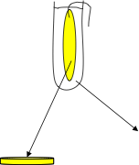

dH2O Outside the Bag (OB)

Solution A Inside the Bag (IB)

IB: Soln A

Before you set up the dialysis, test your IB and OB for starch, salt, glucose and proteins

Testing IB and OB for starch, salts, glucose and proteins

OB: dH2O

(IB1) AgNO3

(IB2) Iodine
Uriscan
(OB1) AgNO3

(OB2) Iodine

Uriscan

Method for testing IB and OB before performing the dialysis
Test for | Test Reagent | Method for Conducting the test | (+) or (-) result | Appearance
NaCl | 0.1M Silver nitrate (AgNO3) | Transfer 2mL of solution to a clean test tube. Add 2 drops of silver nitrate. | + | White precipitate
NaCl | 0.1M Silver nitrate (AgNO3) |  | - | No precipitate
Starch | Iodine reagent | Transfer 2mL of solution to a clean test tube. Add 2 drops of iodine reagent. | + | Purple-black
Starch | Iodine reagent |  | - | Yellow
Glucose | Uristix/Uriscan | Dip a Uristix/Uriscan strip into the solution. Blot off excess fluid. Wait 60 seconds then read the colour chart | + | Colour change-read concentration from chart provided
Glucose | Uristix/Uriscan |  | - | No colour change
Protein | Uristix/Urican |  | + | Colour change- read concentration from chart provided
Protein | Uristix/Urican |  | - | No colour change
Label 4 test tubes IB1, IB2, OB1 & OB2 and follow the instructions in the table below to test for NaCl, Starch, Glucose and Protein for IB and OB and record your results in table 1 in the results section.

Method to set up for Dialysis
Test Solution A and dH2O for each solute
(Note: this could be done after setting up your dialysis tubing at Step 6)
- Transfer 1 mL of Solution A into each of 3 small clean test tubes (label the tubes)
- Transfer 1 mL of dH2O into each of 3 small clean test tubes (label the tubes)
- Test the solution A and dH2O for the presence of the solutes NaCl, starch, glucose and protein (see page 3 for the methods and see footnote1). Record your results in Table 1.
Set up the dialysis
Step 1: Using the 50mL beaker, soak the 30-40cm piece of Cellulose tubing in dH2O for 2-5 mins then remove the tubing and twist and double tie one end.
Step 2: Insert the funnel into the open end of the bag and pour 20mL of solution A into the bag.
Step 3: Gently press the sides of the bag to remove the air, leave 2cm space above the solution then twist and double tie the open end of the tubing.
Step 4: Over the sink, rinse the outside of the bag with dH2O to ensure that no solution A is contaminating the outside of the bag. Blot off excess water and check to make sure there are no leaks in your bag.
Step 5: Use the electronic balance to weigh the bag and its contents – record the mass in grams.
Step 6: Place the cellulose bag in a 100mL measuring cylinder (or similar vessel) of dH2O; use an elastic band or string to tie the top of the bag over the lip of the cylinder so the bag is suspended in the water. If necessary top up the cylinder with dH2O to fully cover the solution in the bag. Sit at room temperature for at least 30 minutes (it can be left overnight).
Step 7: After at least 30 min dialysis
- Remove the dialysis bag from the container, blot off the excess fluid and weigh it. Record the mass.
- Label a clean beaker IB. Hold the bag over the beaker and chop off the bottom with scissors so that the IB solution falls into the beaker.
- Label clean test tubes IB and OB (2 each). Transfer 1mL of IB and OB solutions into the relevant test tubes for the silver nitrate and iodine tests.
- Test the inside the bag (IB) and outside the bag (OB) solutions with the Uriscan strips.
- Record your results in Table 2.
Clean up
All solutions can be tipped down the sink. Wash all tubes and beakers thoroughly.
Note: The very high glucose concentration in Solution A gives a dark brown colour reaction on Uriscan strips because it is higher than the maximum value detected by the test strip. The same may apply to protein.

Results:
Table 1: Solutes found inside the bag (IB = solution A) and outside the bag (OB = dH2O) before the dialysis is performed
Test for | Inside the bag before dialysis (Solution A) |  |  | Outside the bag before dialysis (dH2O)
 | Appearance | Result  (+ or -) | Concentration  (If known) | Appearance | Result  (+ or -) | Concentration  (If known)
NaCI
Starch
Glucose
Protein

Mass of cellulose bag:
Before Dialysis= ________________ After Dialysis= ____________
Calculate the change in mass:

Test for | Inside the bag before dialysis (Solution A) |  |  | Outside the bag before dialysis (dH2O)
 | Appearance | Result  (+ or -) | Concentration  (If known) | Appearance | Result  (+ or -) | Concentration  (If known)
NaCI
Starch
Glucose
Protein
Table 2: Solutes found inside the bag (IB) and outside the bag (OB) after dialysis is performed
Evaluation of experimental procedures

- Why did you perform a test on what was inside the bad (Solution A) and what was outside the bag before performing dialysis?

- Give two reasons for using the four solutes used in this experiment to explore movement across a cellulose semi-permeable membrane?

- Why was it important to rinse the outside of the bag with dH2O before performing the dialysis experiment?

- What was the purpose of weighing the bag pre and post dialysis?

Analysis, evaluation and interpretation of results
- Was there any evidence of osmosis occurring in this experiment? Use evidence to justify your answer.

- On the diagram below, indicate which molecules were able to move across the membrane and the direction of movement.


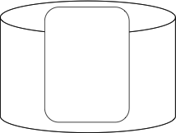
Inside the bag

- Explain why these molecules moved in the direction indicated on the diagram.

- Which molecules could not move across the cellulose tubing?

- Suggest why the molecules names by you in question 8 did not cross the membrane.

Application of theory to movement of substances across membranes
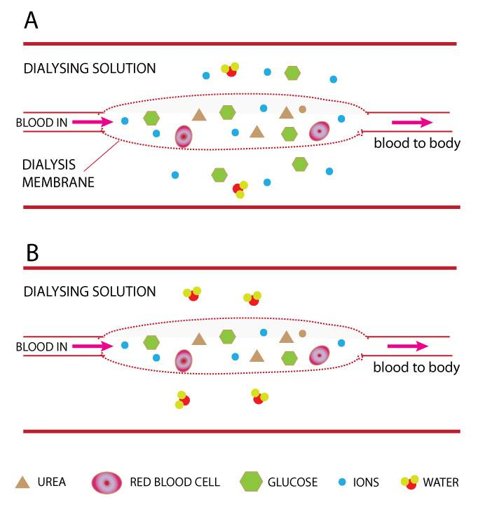
- People with kidney damage undergo dialysis to get rid of nitrogenous-wastes like urea from their blood. However, it is important to keep the correct concentration of glucose and electrolytes in the blood stream – you don’t want to lose all of them to the dialysis machine. Which of the diagrams (A or B) shows the best dialysis solution to use so that blood returning to the body has normal solute levels? Justify your answer.

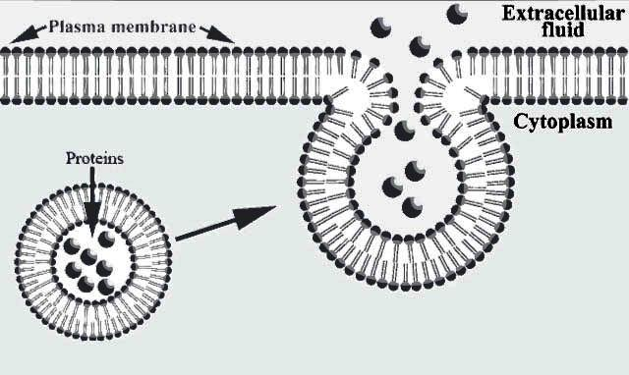
- Proteins are too large to move across cell membranes by simple diffusion. Name and briefly describe the process illustrated in the diagram.

12. Movement of substances across the cellulose tubing in this experiment is not an accurate representation of how substances move across cell membranes.
a) Which type of diffusion does this dialysis experiment demonstrate?

b) Using the appropriate terms, such as passive diffusion, facilitated diffusion and active transport, annotate the fluid mosaic model of a cell membrane to indicate how glucose, ions and water move across cell membranes. In the box name and then below describe the process of movement for each substance.
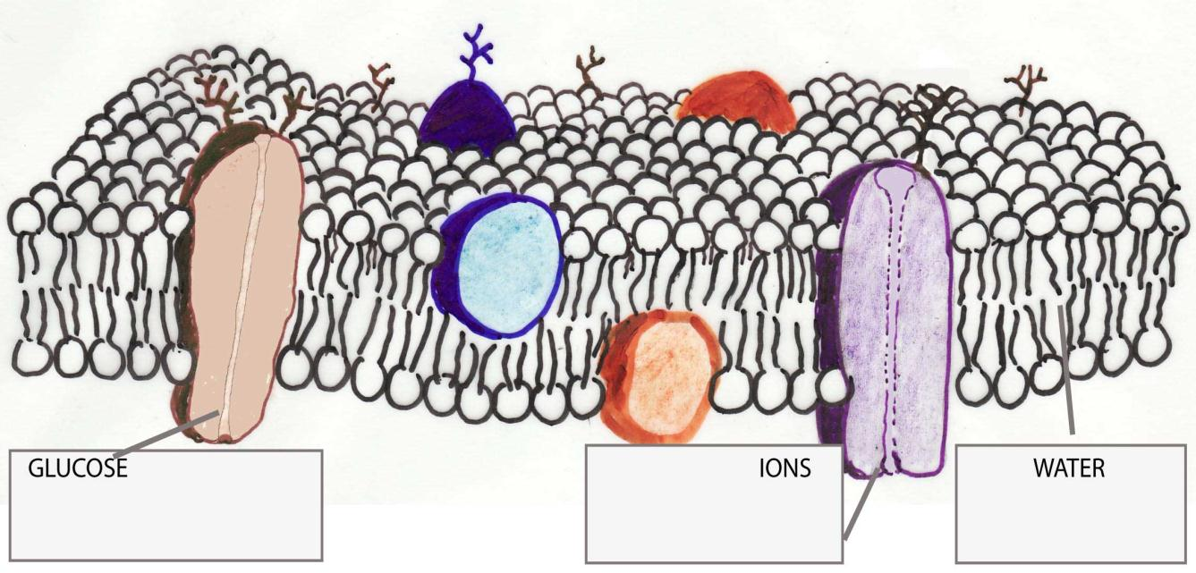
GLUCOSE:
______________________________________________________________
______________________________________________________________
______________________________________________________________
IONS:

______________________________________________________________
______________________________________________________________

WATER:

______________________________________________________________
______________________________________________________________

This SAC was sourced from: Gene Technology Access Centre (GTAC) 2013b, ‘Unit 3 Outcome 1 SAC task 3, Dialysis: An investigation of movement of substances across membranes, Gene Technology Access Centre (GTAC), retrieved 10 October 2013, <http://www.gtac.edu.au/site/teacher_access/teacher_access_resources/Unit3-Study1-Outcome1/Task3-Student%20WB_Unit%203_Outcome%201%20dialysis%20SAC.pdf>

Marking criteria
VCE Biology An investigation of the movement across membranes
Marking descriptors aligned with VCAA key knowledge and skills:

(The performance descriptos were adapted from: VCAA, VCE Biology Assessment Handbook 2013-2016, V.C.a.A.A. (VCAA), Editor 2012, VCAA: Melbourne).

Key Skills and knowledge being assessed | Performance | Mark | Evidence
Collection and presentation of results and safe laboratory practice /4 | Detailed and accurate collection and presentation of results and safe laboratory practice | 4 | Laboratory practice  Use of MSDS for safety considerations practice  Presentation of results
 | Accurate collection and presentation of results and safe laboratory practice | 3
 | Some accurate collection and presentation of results as well as safe laboratory practice | 2
 | Limited presentation of results or safe laboratory practice | 1
Evaluation of the procedures of the practical /5 | A comprehensive evaluation of the procedures of the practical investigation | 5 | Questions 1-4
Evaluation of the procedures of the practical /5 | A well-developed evaluation of the procedures of the practical investigation | 4 | Questions 1-4
Evaluation of the procedures of the practical /5 | Identification and some evaluation of the procedures of the practical investigation. | 3 | Questions 1-4
Evaluation of the procedures of the practical /5 | Identification and some discussion of the procedures of the practical investigation. | 2 | Questions 1-4
Evaluation of the procedures of the practical /5 | The results of the practical investigation are identified. | 1 | Questions 1-4
Analyse, interpret and evaluate results of the practical /8 | Comprehensive and detailed analysis, evaluation and interpretation of the results. | 8 | Questions 5-9
Analyse, interpret and evaluate results of the practical /8 | Very detailed analysis, evaluation and interpretation of the results. | 6-7 | Questions 5-9
Analyse, interpret and evaluate results of the practical /8 | Some detailed analysis, evaluation and interpretation of the results. | 4-5 | Questions 5-9
Analyse, interpret and evaluate results of the practical /8 | Some knowledge and understanding of the results. | 2-3 | Questions 5-9
Analyse, interpret and evaluate results of the practical /8 | The procedures of the practical investigation are identified. | 1 | Questions 5-9
Demonstrate and apply knowledge of the terms concepts and relationships associated with applications of molecular biology in terms of the structure and function of the plasma membranes including the fluid mosaic model of the plasma membranes and types of movement of bio macromolecules (specifically proteins) across membranes. /8 | Comprehensive and detailed knowledge of terms, concepts and relationships of the relevant theory in relation to applications of molecular biology related to the movement of substances across membranes. | 8 | Questions 10-12
 | Very detailed knowledge of terms, concepts and relationships of the relevant theory in relation to applications of molecular biology related the movement of substances across membranes. | 6-7 | Questions 10-12
 | Adequate knowledge of terms, concepts and relationships of the relevant theory in relation to applications of molecular biology related to the movement of substances across membranes. | 4-5 | Questions 10-12
 | Some knowledge of terms, concepts and relationships of the relevant theory in relation to applications of molecular biology related to the movement of substances across membranes. | 2-3 | Questions 10-12
 | Limited knowledge of terms, concepts and relationships of the relevant theory in relation to applications of molecular biology related to the movement of substances across membranes. | 0-1 | Questions 10-12

